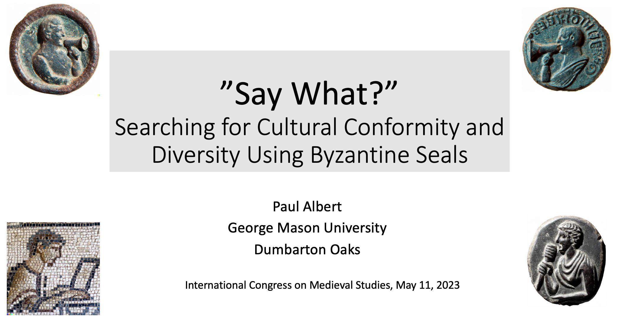

Hello,

This talk discusses the ideas of cultural conformity and cultural diversity and what a quantitative investigation of data on Byzantine seals might indicate in this regard. [SLIDE]

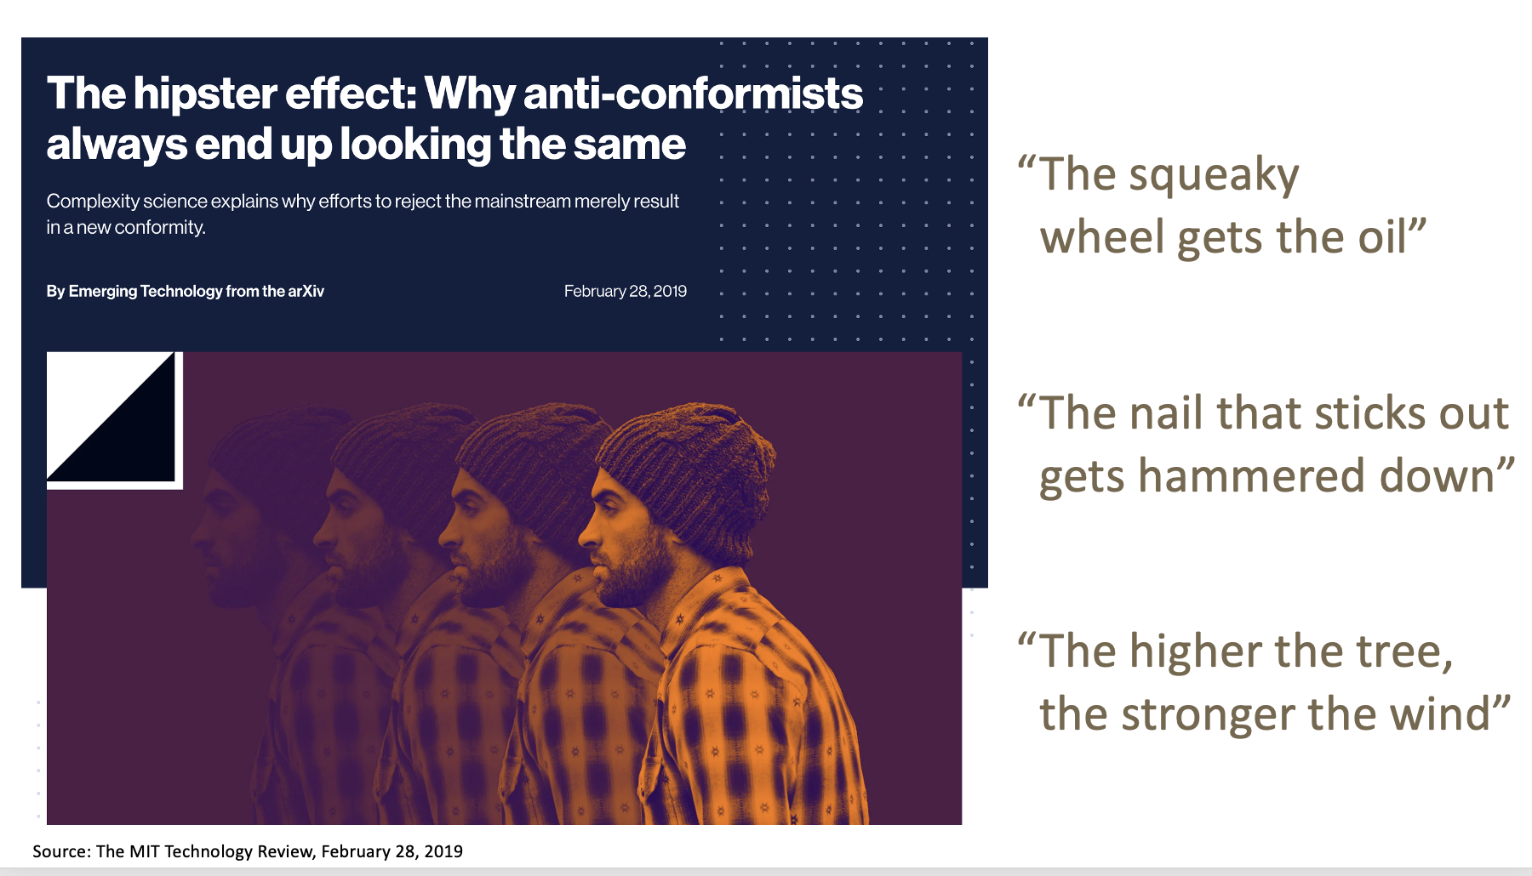

(<https://www.technologyreview.com/2019/02/28/136854/the-hipster-effect-why-anti-conformists-always-end-up-looking-the-same/>)

In 2019, the MIT Technology Review covered a study out of Brandeis University that reached the conclusion, that when nonconformists attempt to stand out, they often end up looking quite similar to each other. The researchers called this phenomenon “the hipster effect.” This term inspired the publication to use the picture shown for illustration.

Soon after the publication of the article, the journal received an angry letter promising swift legal action from a man claiming that this was a picture of him, used without permission. In investigating his claim, the journal found that the picture, taken from a stock image archive, was, in fact, of a different person. The publication then went on to tweet about this incident asserting that this misunderstanding actually helped prove the study’s argument, that in attempting to be non-conformist, hipsters end up looking pretty much the same. This was a brilliant marketing move that gained the article much more press than it got when first published!

The study’s overall topic, cultural conformity and cultural diversity, has long fascinated social researchers. It is a theme that goes back at least as far as Alexis de Tocqueville’s book *Democracy in America*.

For example, here in the United States, there is a popular phrase “the squeaky wheel gets the grease,” [CLICK] often understood to mean that standing out from others is a positive thing. In contrast, people often point to the Japanese aphorism “the nail that sticks out gets hammered down” [CLICK] or the Chinese aphorism “the higher the tree the stronger the wind” [CLICK] to suggest that these cultures value conformity more than diversity.

To be sure, almost by definition, the very concept of culture suggests that there is some level of conformity existing on which to build group identity. At the same time, it seems a very human instinct to seek some degree of distinction within a group. I suggest that these two paradoxical drives exist throughout the human condition. We all want to fit in, but we all also want to stand out.

This paper attempts to computationally examine the seals of the Dumbarton Oaks Online Byzantine Seal Catalogue to look at several dimensions of conformity and diversity across centuries in the Byzantine world. After all, Byzantine Lead seals are sociocultural artifacts, material expressions of the culture in which they were developed and used. [SLIDE]

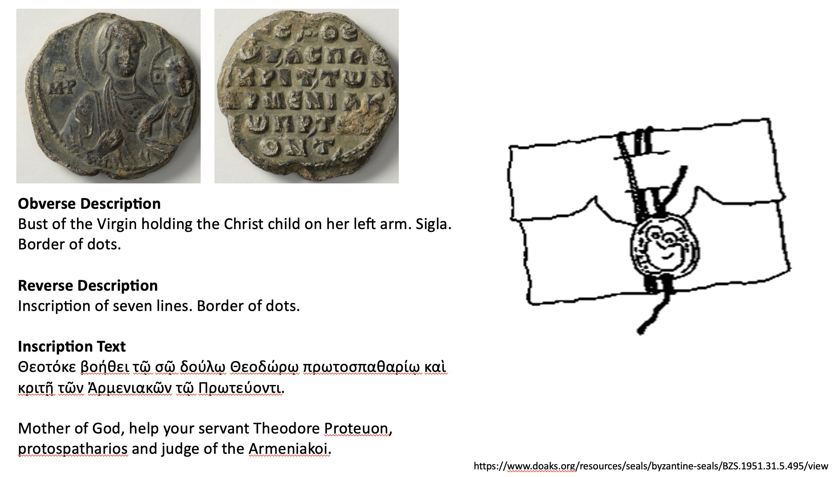

Here is one example of a Byzantine seal from the catalog.

On the left, we see some of the data attributed to this seal. On the right, we see a diagram of how a seal was used to fasten a document. A thread was passed through both the document and a seal blank and then locked into place by physically striking and embossing the seal’s image and text onto the blank.

Possible reasons why seals were likely utilized include authenticating the sender of the document, assuring that the document was not tampered with, indicating the prestige of the sender, and imparting some level of gravitas to the document being sent.

For anyone who relates to all the thought that goes into selecting a wedding invitation where verbiage, paper type, font, and stamp choices are all endlessly pondered, I would not find it surprising to think that similar considerations were taken by the owners of these seals. Like with the choice of all the specifics around a wedding invitation, the choice of all the specifics around a Byzantine seal, and indeed the use of the seal, is inherently a cultural act.

The sheer number and diversity of Byzantine seals and their owners make these seals unique cultural artifacts particularly worthy of study. Compared to other artifacts that survive from the Byzantine world, such as written records or coins, we have a relatively larger number of unique examples representing a relatively wider cross-section of society. This paper draws from a dataset of 12,235 seals whose owners ranged from bathhouse administrators and butchers to monks and notaries to generals and emperors.

My original hypothesis going into this project was that if we look at the conformity and diversity among what these seal owners chose to say and put on their seals, and compared this across centuries, we might be able to gauge how overall cultural values around conformity and diversity might have changed. To cut to the chase, what I’ve found on my journey are mixed messages and a new realization that it probably doesn’t make sense to characterize a culture as valuing similarity over diversity or vice versa.

To obtain my data, I programmatically scraped the Dumbarton Oaks Catalogue website and built a database recording various information about each seal. I then created a subset of seals to look at just seals with Greek inscriptions from between the 7th and 12th centuries that had complete inscriptions. Thus, rather than the full corpus of the 15,000+ seals from the online catalog, this paper just looks at a subgroup of 12,235 seals. Not a huge number compared to some contemporary cultural analytics studies, but still a pretty healthy dataset. [SLIDE]

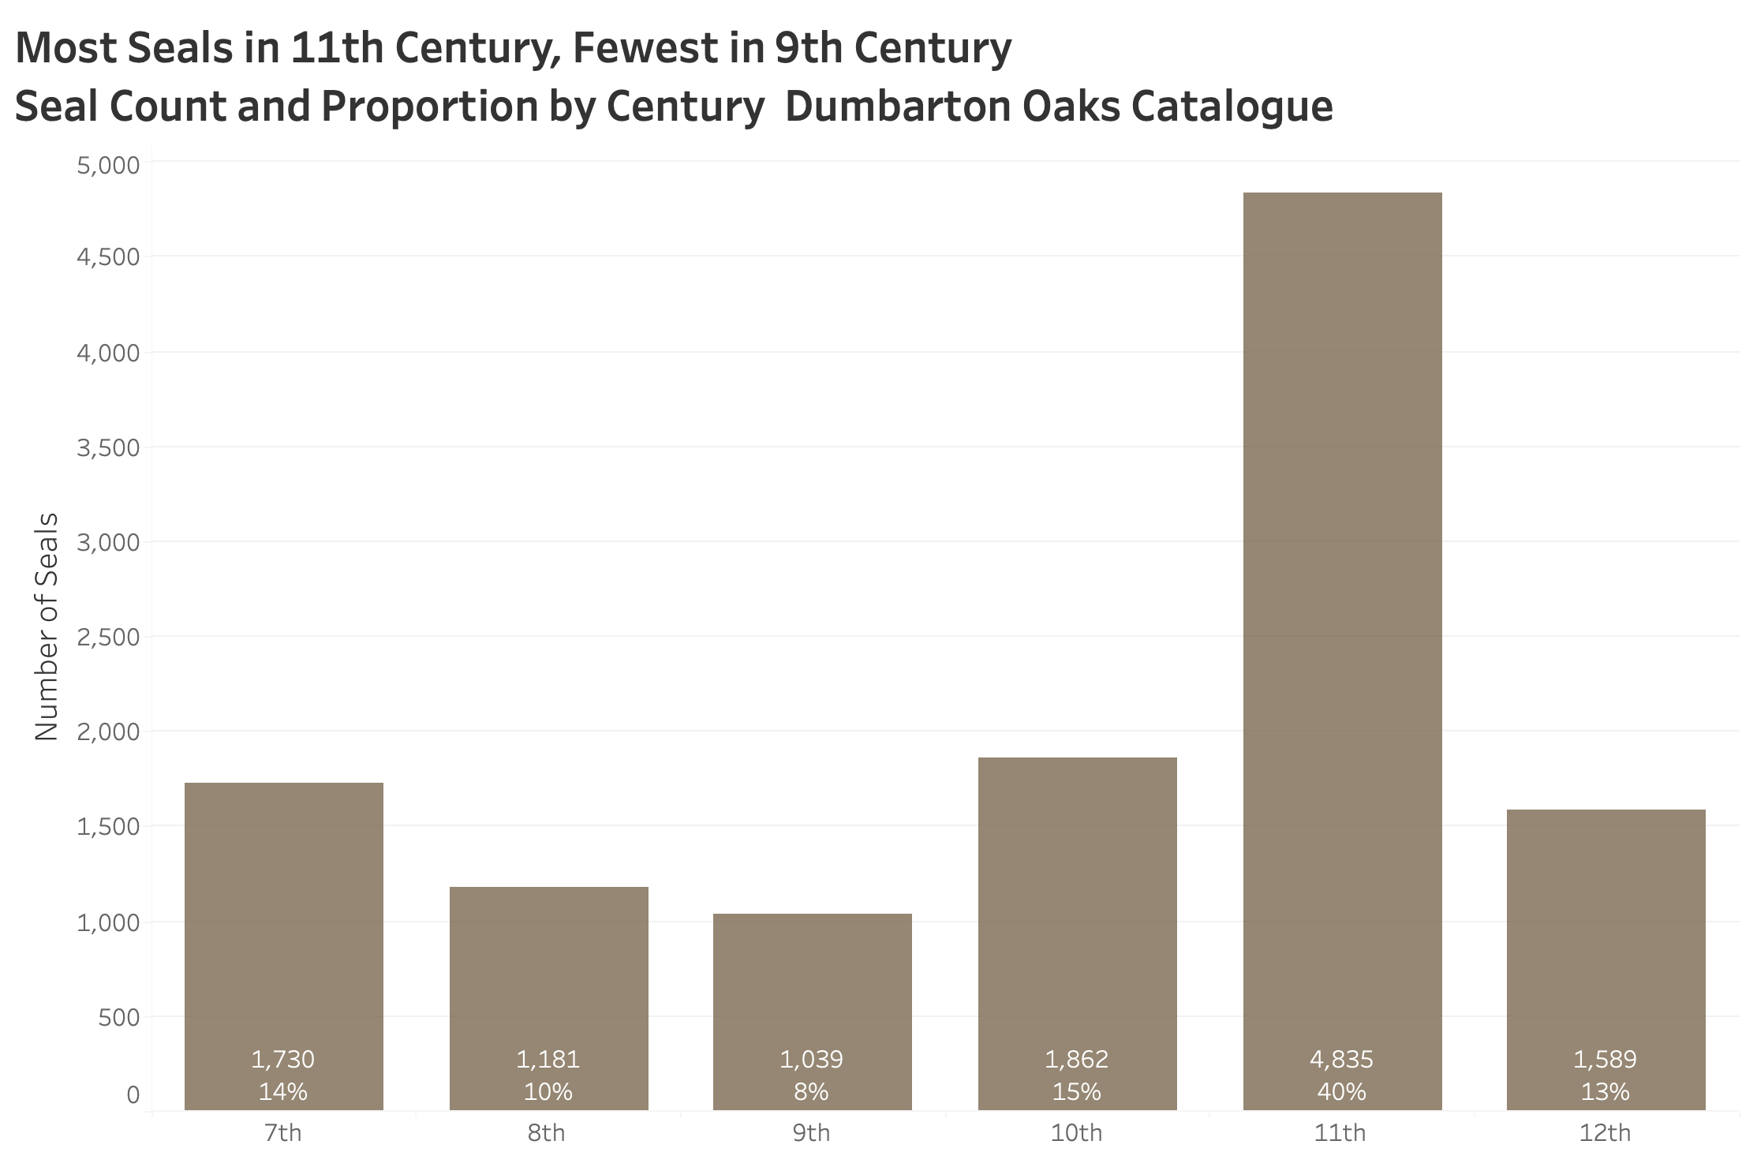

This slide shows the count and proportion of the seals in my data by century.

What we can see is that there is quite a difference in the number of seals in our data between the centuries. A huge proportion, 40% of the seals in the data are from the 11th century. To me, this prompts the question, were seals that much more ubiquitous in the 11th century in historical reality or is our sample somehow biased? Could it be that for some reason, seals of the 11th century somehow survived at a greater rate than seals of other centuries?

This is a great question, and one this paper does not attempt to answer. I point out this important, and somewhat obvious, question however as a demonstration of the value of looking at these seals in a quantitative way. Much of the literature, with the very notable exception of John Cotsonis, examines patterns between different unique seals, not patterns between different groups of seals. While the former approach provides tremendous value and insight, a computational approach gives us a complementary lens to add to our understanding. Using this additional lens not only helps us better interpret what we find between individual seals but also hopefully helps us ask new and better questions.

I will note that this talk’s research question “What can seals tell us about how cultural values around conformity and diversity have changed over time?” can really only be investigated by computationally looking at patterns and differences among groups of seals, not by looking at individual seals themselves.

Since this is a different way of investigating history, this approach has its own unique limitations. Though this paper presents a lot of graphs and numbers, I urge the audience not to gain a false sense of definitiveness from my findings. This paper offers a computational interpretation of textual interpretations of unique physical objects. While my numbers themselves are precise, my findings are merely suggestive. At best, they are just an abstraction of an abstraction of an infinitely complex reality.

Let us take a look at what I’ve found. [SLIDE]

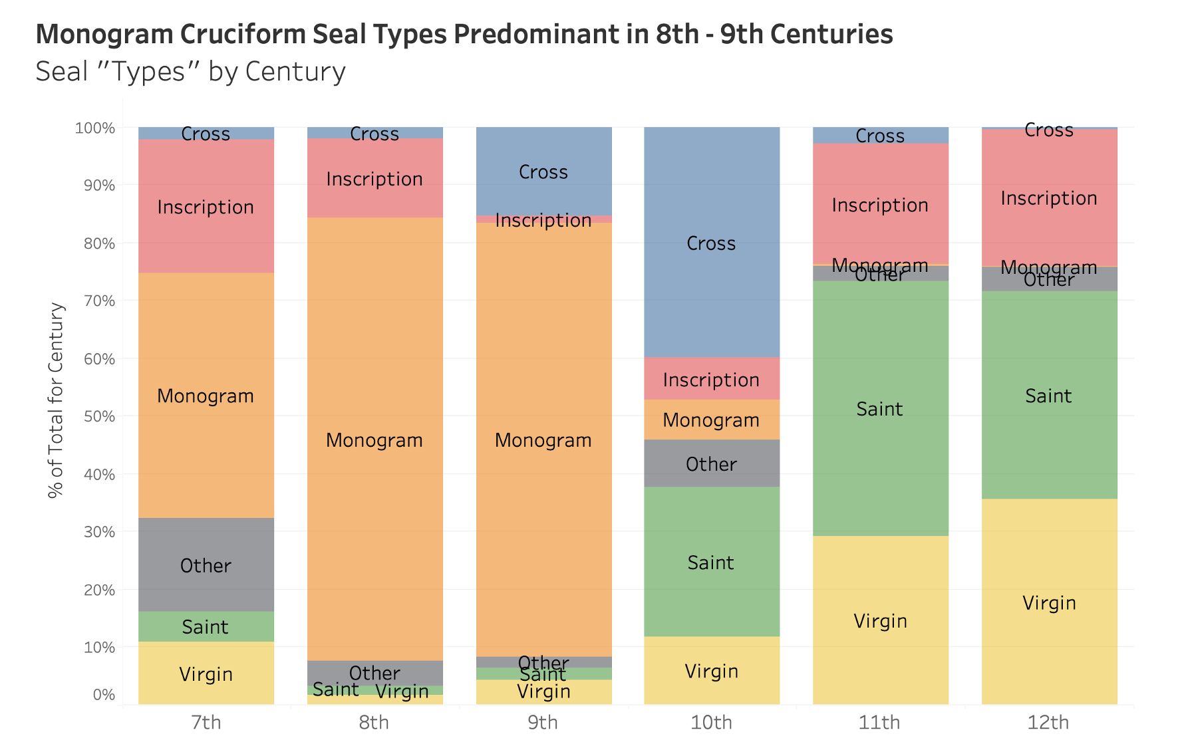

In working with the seal data, I used the text describing the obverse of each seal to programmatically assign the seals to one of six different seal types. Saint, Virgin, Inscription, Monogram, Cross, and Other. Here is the relative distribution of each seal type by century.

Notably, we can see that while the Monogram seals are especially dominant in the 8th and 9th centuries, other seal types became much more prevalent in the data after this.

If we just eyeball this chart, it is easy to conclude that there was greater similarity among seal types in the 8th and 9th centuries than in the other centuries.

Luckily for us, there are various quantitative methods we can use to more precisely gauge the conformity of the seal types within each century shown here. [SLIDE]

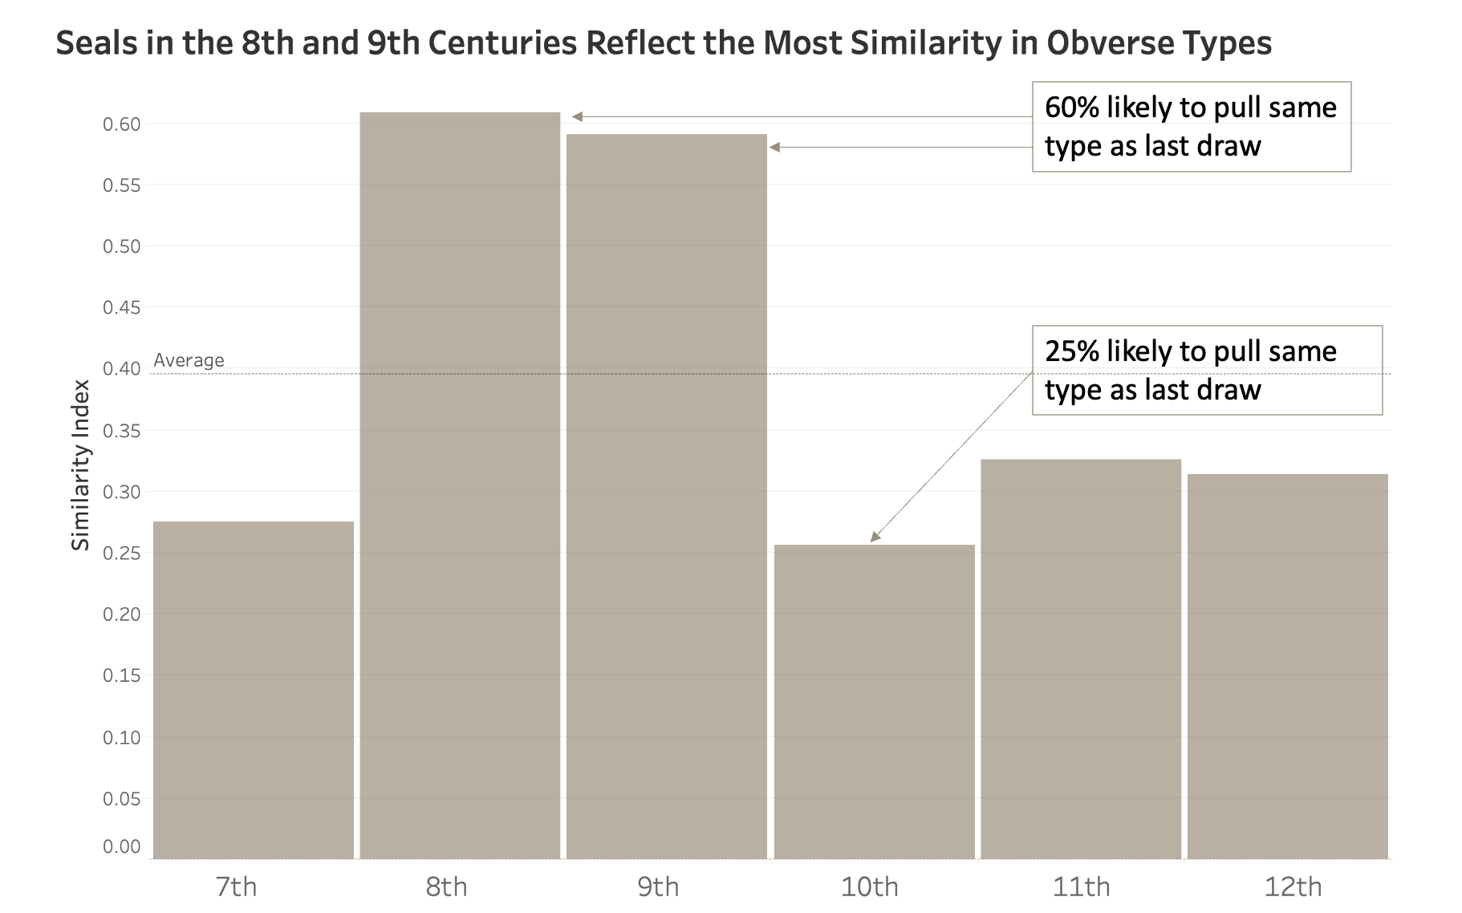

For this project, I’ve borrowed one of the most common techniques used in biostatistics to measure species diversity within a given ecology, the Simpson Index of Similarity.

The higher the Index value, the more similar the population. Statistically speaking, a good way to interpret these index values is to hypothesize that we put all the seals from each century into different buckets and give each bucket a good mixing. If we started reaching into the buckets for the 8th or 9th centuries and pulled out a seal and then put it back into the bucket and mixed them again, we have about a 60% chance of pulling the same seal type on our next draw as we did from our last draw. [CLICK] In contrast, if we did that for seals from the 10th century, we’d have only about a 25% chance of pulling the same seal type on our next draw. [CLICK]

Looking at this dimension of investigation, seal obverse type, the seals of the 8th and 9th centuries indicate strikingly more conformity than seals from other centuries. [SLIDE]

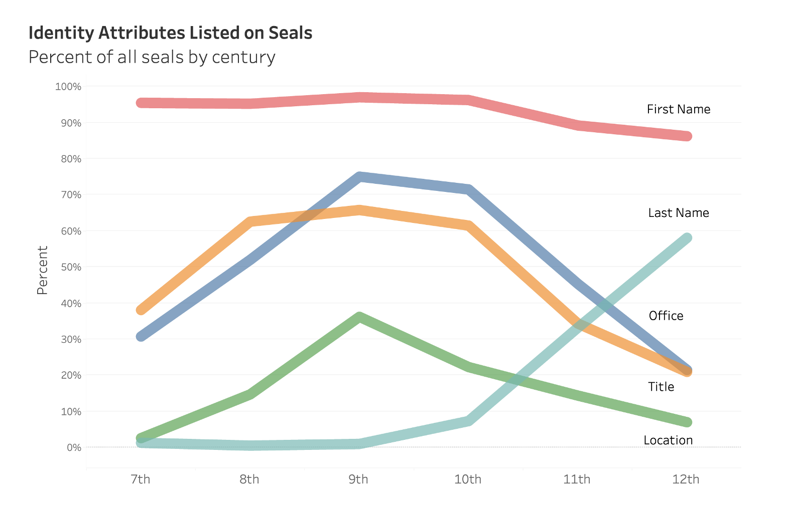

Diving a little deeper, we can turn to the information elements contained on the seals that help distinguish the owner’s identity. We find that these elements were used in different proportions between centuries.

This chart shows, that while listing the seal owner’s first name was a relatively constant and predominant practice across all the centuries, the family name of the seal owner only started showing up in meaningful proportions in the 10th century.

I also find it quite striking how seals around the 9th century tended to list the owner’s Office, Title, and Location at a significantly greater rate.

Let’s look at the seal owners' first names as our next dimension to investigate conformity vs diversity. [SLIDE]

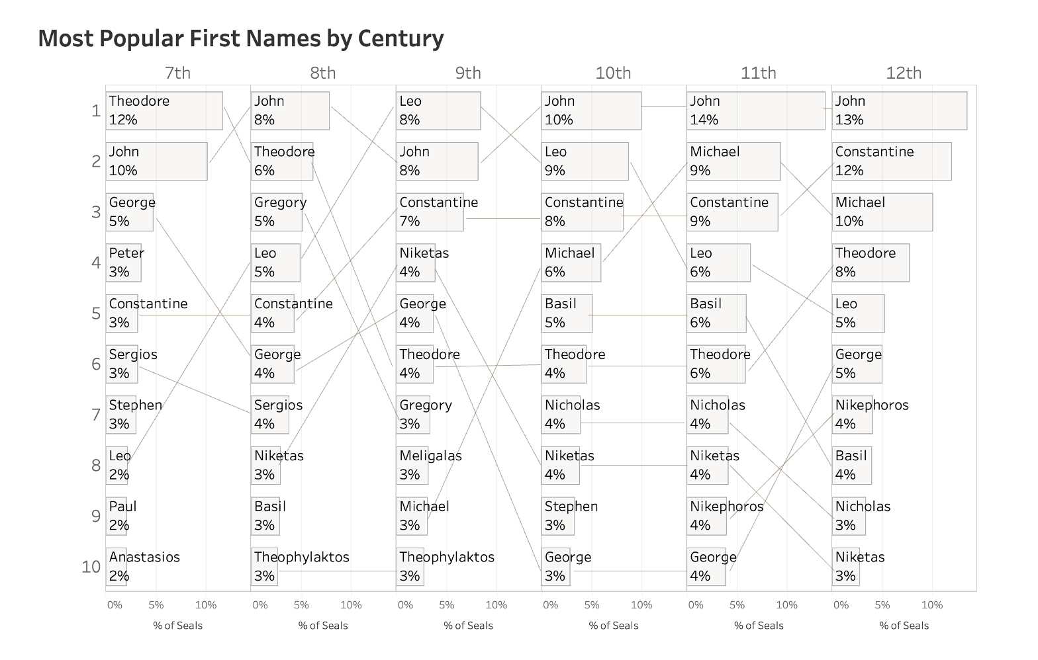

This slide shows the top 10 seal owners' first names used in each century and their proportions.

It stands to reason that a name given to a child is purely a culturally driven act. Given that, perhaps, in eras where there is more cultural conformity, the range of first names would reflect less diversity.

Interestingly, there is an actual real-world experiment we can look at to test this hypothesis. For 40 years, present-day Germany was divided in two. West Germany, a country we might think of as embodying an ethos that valued diversity, and East Germany, a country we might think of as embodying an ethos that valued conformity. In 2009 a group of researchers looked at the diversity of first name usage given to children during the split between the two countries. The question they asked was “Was first name usage less diverse in the hypothetically conformist East Germany or the hypothetically diverse West Germany?”

Let me poll the audience on what they think was found. Please don’t be shy and raise your hands! First, can I see a show of hands … how many people think East Germany had a greater diversity in first names than West Germany? ….. Second, how many people think West Germany had greater diversity than East Germany?

In fact, neither choice is what was found. The researchers concluded that there were, in fact, no statistical differences between the two countries in name diversity. [SLIDE]

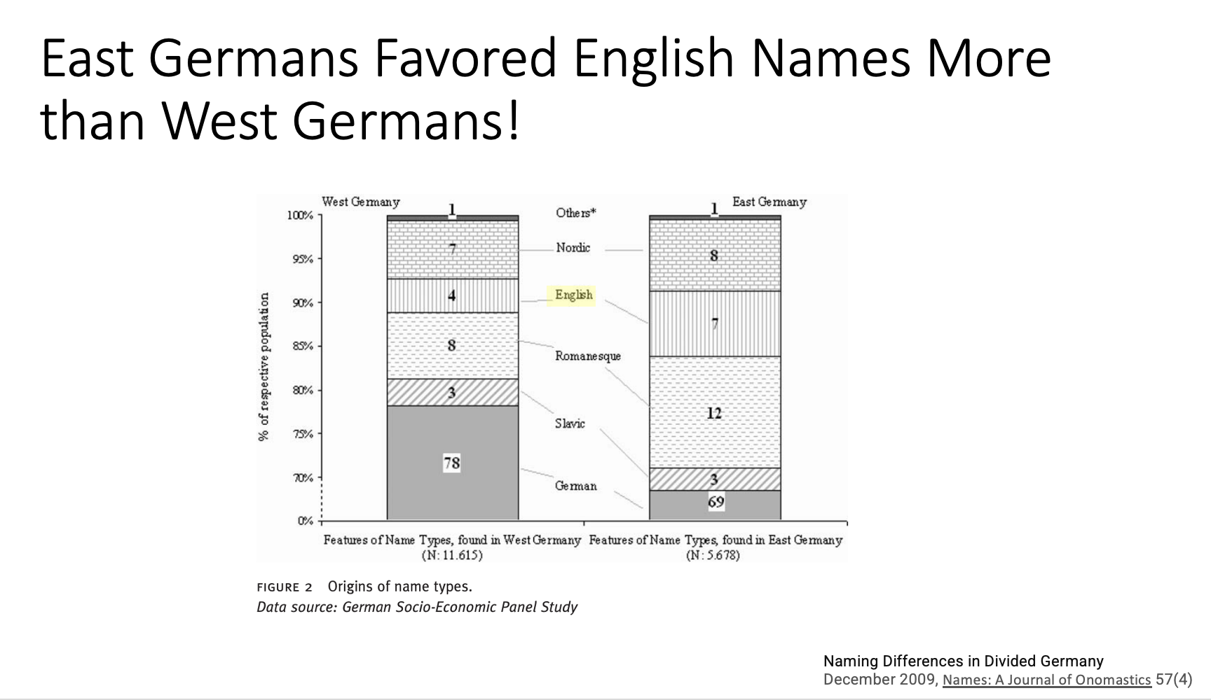

https://www.researchgate.net/profile/Denis-Huschka/publication/228911223_Naming_Differences_in_Divided_Germany/links/0c960520a04f28e1e7000000/Naming-Differences-in-Divided-Germany.pdf

Surprisingly, however, the study found that while West German parents gave their children English first names 4% of the time, East German parents gave their children English first names 7% of the time. Almost double the rate. Indeed, the researchers note that anecdotally, both East and West Germans considered the names “Mandy,” “Cindy,” and “Mike” as uniquely signaling a person as being from East Germany.

If these findings are not enough to make one want to chuck everything and just study cultural naming practices, I don’t know what is.

So, with that aside, what does our seal data show in terms of first name diversity? [SLIDE]

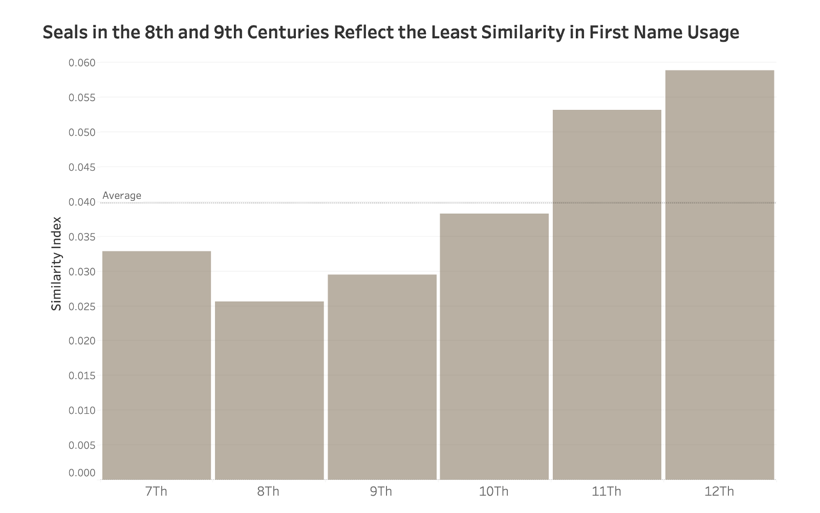

While seals in the 8th and 9th centuries reflected the most similarity in seal types, they show the least similarity among first names. For this dimension, they indicate relatively less conformity!

At least for these two dimensions and these two centuries, we are getting a conflicting message.

Now, let us now turn to what the inscriptions on the seals said as another dimension to use in our investigation. [SLIDE]

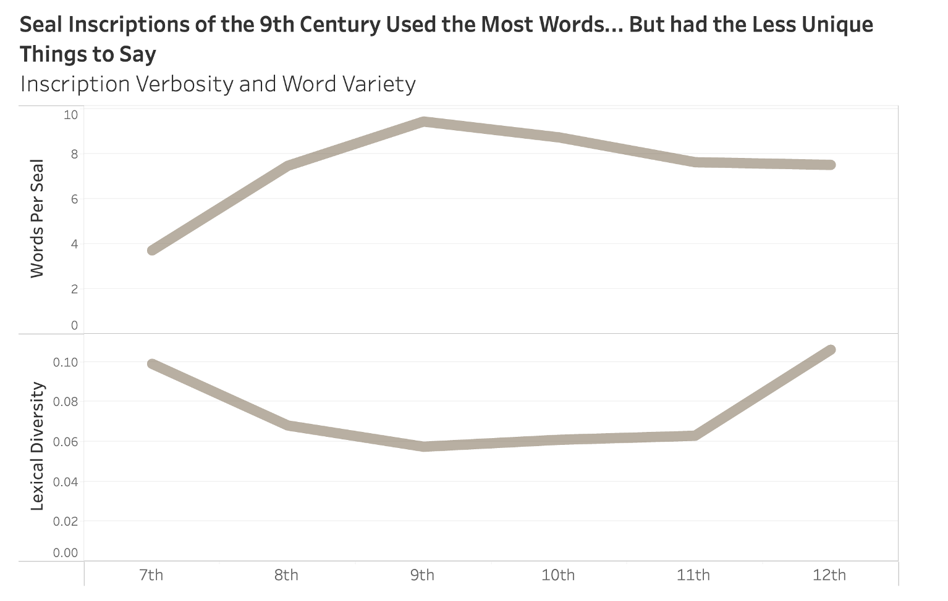

On the top pane of this chart, we can see that the seals from the 9th century had the most average inscription words per seal. On the bottom pane of this chart is a measure of Lexical Diversity. Lexical Diversity is simply derived by taking the count of unique inscription words and then dividing it by the count of the total number of words for each century.

Interestingly, while the inscriptions of the 9th century were the most verbose, these inscriptions had the least different unique things to say. For every hundred inscription words on seals from the 9th century, we find only six of them to be unique. In the 12th century, this is almost doubled, we find about 12 unique words. [SLIDE]

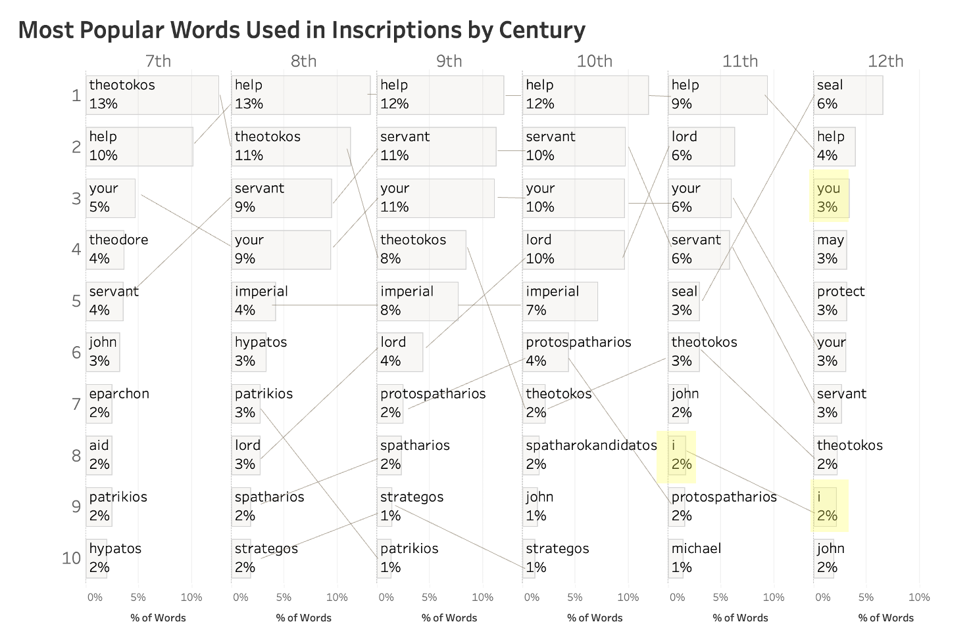

Here is a look at the top 10 words used by century with some common stopwords such as “and”, “of”, and “the” removed.

Just eyeballing this small list of the 10 words out of the roughly 3,800 unique words used across all the centuries by seal inscriptions we see the top-ranking word was used less frequently in 11th and 12th century.

The focus of my present talk revolves around the theme of conformity and diversity, not the fascinating and related theme of individualism and personal identity. However, I must say I find it interesting that word “I” [CLICK] starts showing up in our top-ten list in the 11th century and is joined by the word “You” in the 12th century. Both words seem likely markers of a growing sense of individualism in this period that has been remarked on in the literature. [SLIDE]

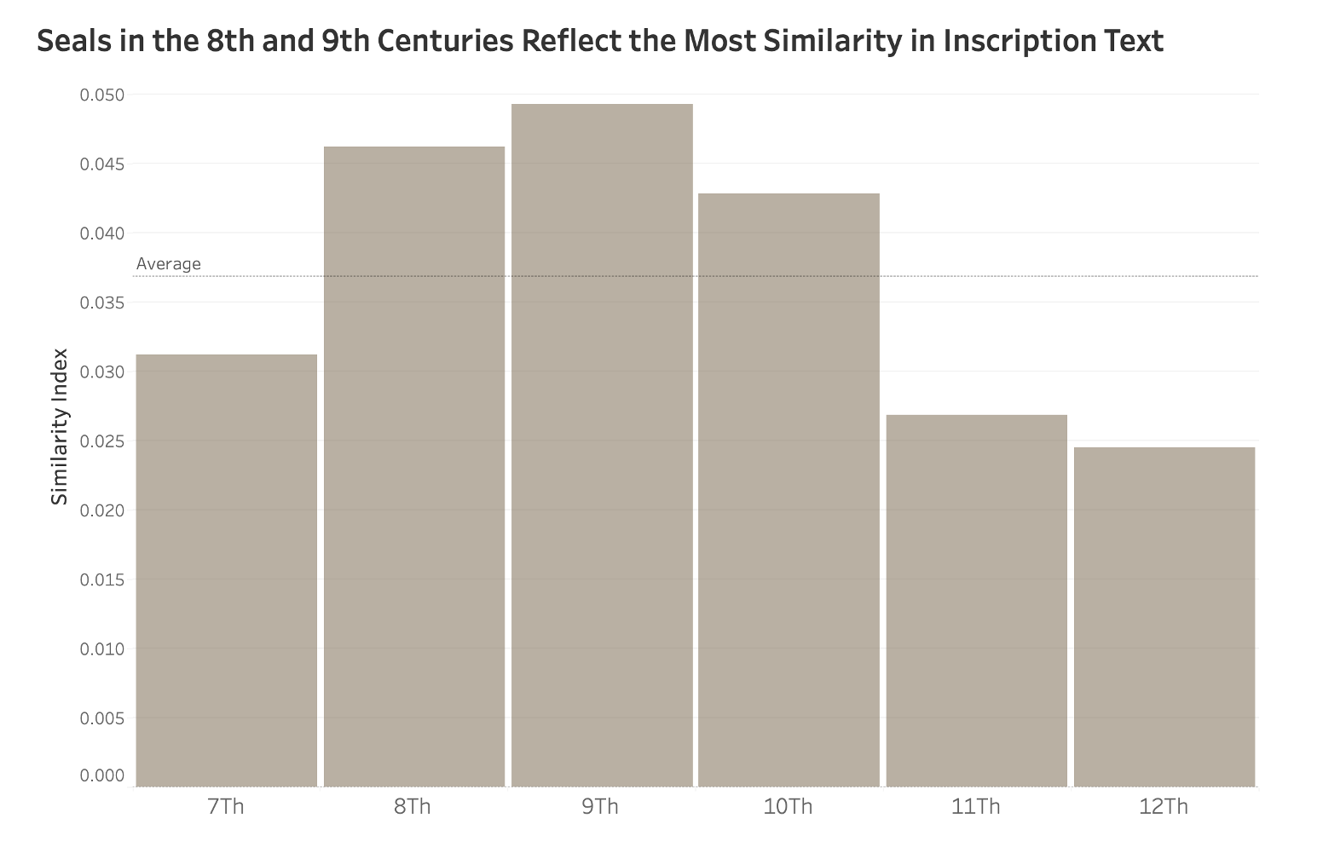

To step back and look at all the words used in inscriptions for each century, here is the same Simpson Index of Similarity that I’ve been using in this talk for the other dimensions investigated.

We see here that seals of the 8th and 9th centuries had the most overall conformity in the words used on seal inscriptions.

Wrap Up

Let me start to wrap up by stating that we began this presentation by suggesting that seals offer a unique view into Byzantine society. Both in terms of their sheer number and wider representativity of a cross-section of society, seals provide evidence in a different way than other surviving artifacts such as coins or written records can provide.

With that in mind, my effort seeks to do some preliminary high-level computational analysis of the seals to investigate different dimensions of conformity and diversity across time. [SLIDE]

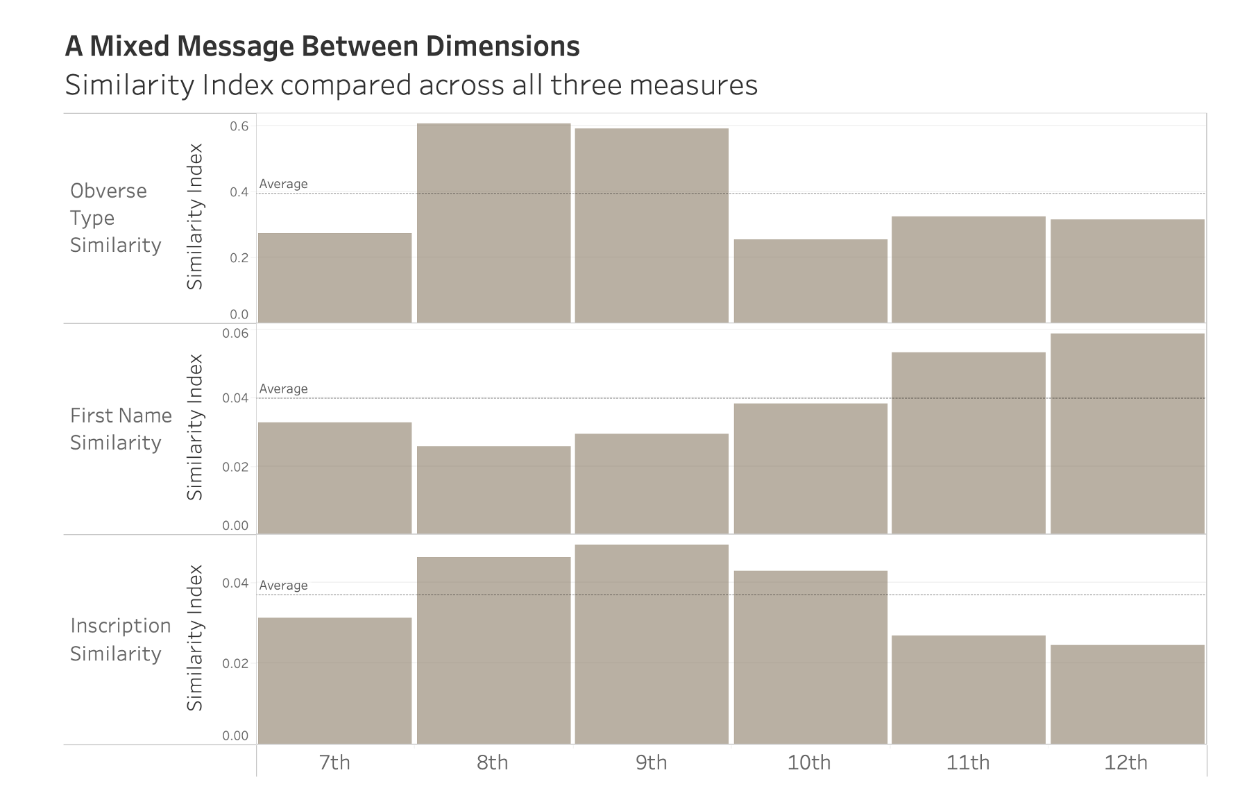

What we have found is a bit of a mixed bag. Our different dimensions are not all agreeing with each other.

Here are all three of the similarity dimensions we explored in one slide.

To make it a bit easier to see which centuries showed relatively more similarity along a dimension, we can look at how each century scored compared to its average line along that dimension. [SLIDE]

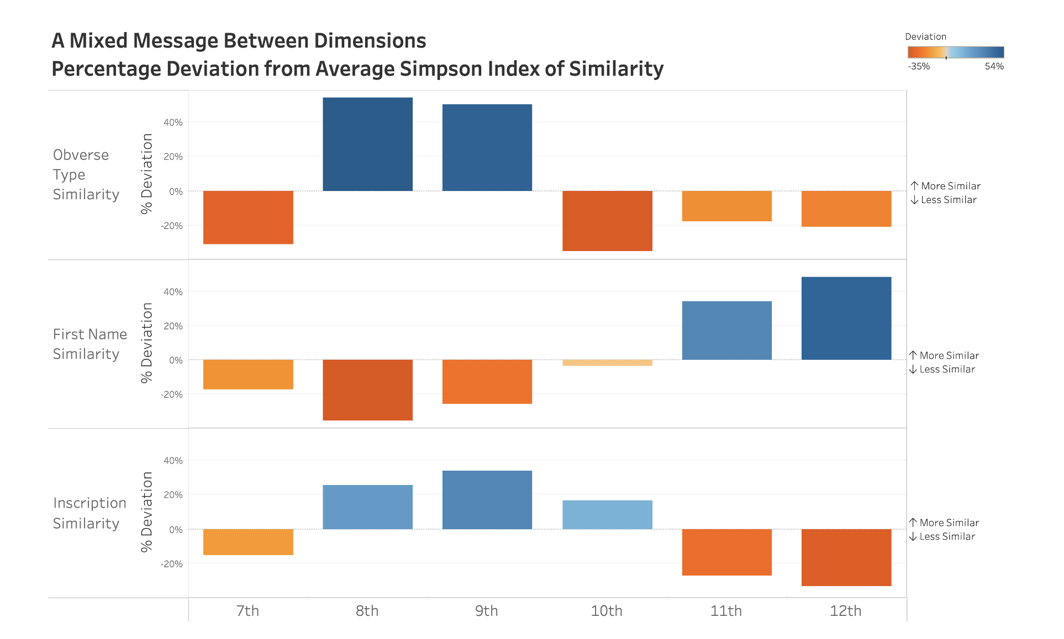

In this graph, blue bars falling above the line indicate instances when a century showed more similarity than the average, and orange bars falling below the lines indicate less similarity. For those looking for easy conclusions, the data is not fully obliging. We see, in general, when Type and Inscription Similarity go up, First Name Similarity tends to go down and vice versa.

To me, this is a really surprising finding. Intuitively, one would expect all of these similarity measures to agree. Seal Type, First Name, and Inscription Verbiage all seem to be valid markers for overall cultural conformity or diversity.

Honestly, my first instinct was to question the relative validity of each dimension. Perhaps one of these is somehow better than the others in reflecting the overall culture?

However, in thinking through this puzzle, I now realize I started my project with a basic misunderstanding of the nature of culture. I began with the implicit assumption that a culture could be characterized as more or less relatively overall conformist. To my chagrin, I now understand that this assumption is actually just an example of the logical fallacy of reification.

Instead, I would suggest that culture is in fact an abstraction, something that emerges from the interactions of its individual members. Even more, when we look at these individuals, I propose that it is intrinsic to human nature that while people want to fit in, they also paradoxically seek to stand out. Considered together, these propositions make it inevitable, that, in any culture at any one time, we would simultaneously find both higher conformity and higher diversity across different dimensions.

This is exactly what this project has found and what this slide shows.

Here it is staring at our faces.

I now realize that, because of its very nature, one cannot characterize any culture as being more overall conformist or diverse. Because I wasn’t expecting this conclusion, this is an insight I particularly value.

On top of being unexpected, this realization also serves as a reminder that when we investigate history or culture using a computational lens, we get different takeaways that other approaches might not readily afford.

What I hope you all have gotten out of this talk is not only a shared appreciation of this insight about the nature of culture but also an appreciation of the value of using a computational lens to explore some of the rich things we can learn from Byzantine seals. [SLIDE]

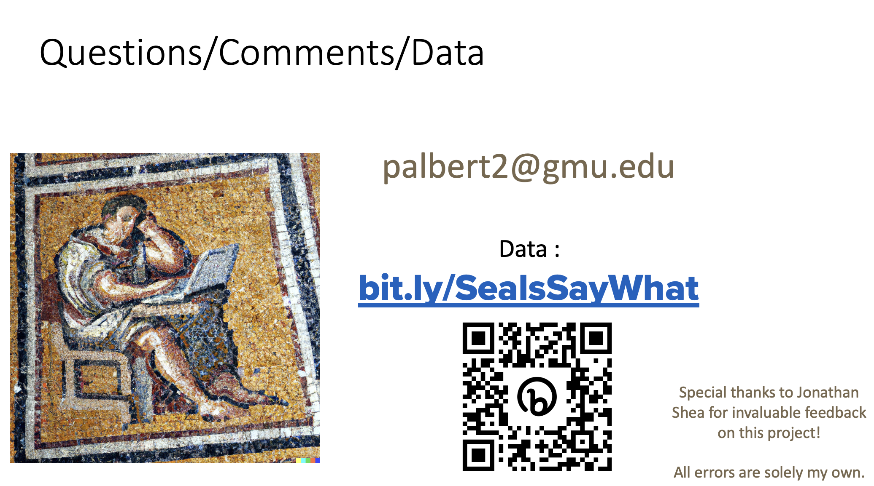

As stated earlier, my work is an abstraction of an abstraction of an infinitely complex reality. I’d find nothing better than for this work to inspire other questions and thoughts from you.

For those of you hankering to work with the Dumbarton Oaks Seal Data yourself, I have shared my work on the web using the site GitHub. Here is the URL and a QR code that leads to the site.

Along these lines, if there is anyone in the audience who has data of their own they are trying to make sense of, I periodically give a free online Digital Humanities focused workshop on using a program called Tableau for data analysis and visualization. I expect to do so again this August.

If you are interested in learning more about this free workshop, or if you have feedback on this paper, please contact me at the email address here.

I commend you all for your interest in Byzantine seals and what they might show. This is a topic that deserves far more attention. Are there any questions or suggestions on where I might want to take my efforts?

Additional findings to possibly discuss during Q&A:

